INDIVIDUAL PROJECT REPORT - SMART CROP HEALTH MONITORING
Member 3: Training and Optimisation Lead
Name | Ranga Rama RaviTeja Chakka | Student ID | 35048212
Module | 55-710603 | Word target | Approx. 2500 words + figures
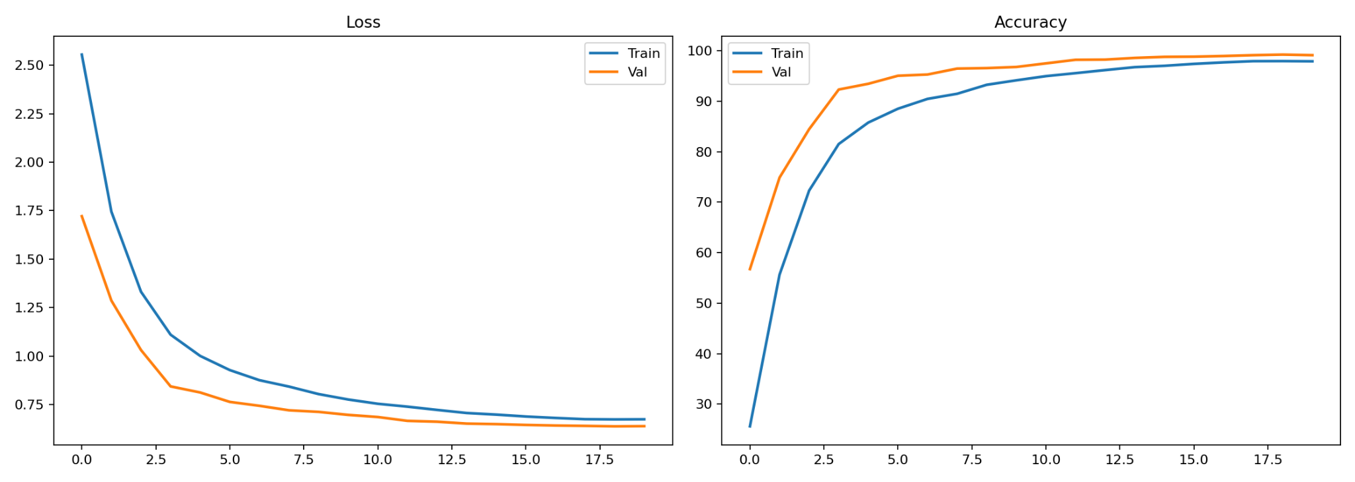
Figure 1. Training and validation loss/accuracy curves.

Part A: Introduction - Problem and Importance
My individual responsibility was training and optimisation of the Smart Crop Health Monitoring model. The project aims to provide an AI-supported plant disease screening system that can classify leaf images into 23 categories across five crops. This matters because plant disease diagnosis is time-sensitive: a delayed or incorrect diagnosis can lead to yield loss, inefficient treatment and avoidable environmental impact. My work focused on turning the architecture and dataset into a stable trained model by selecting augmentation, class-imbalance handling, optimisation settings, checkpointing and export procedures. By Week 10, the model had been trained in Kaggle and transferred into VS Code and Hugging Face deployment workflows.
The significance of the project is not limited to model accuracy. It demonstrates how an AI idea can be developed through the full lifecycle required in the module: problem definition, technical review, design, implementation, evaluation, social impact analysis, project management and future-work planning. The project also produced a live Hugging Face Space, which is important because the final pitch requires a working demonstration rather than static screenshots. In practical terms, the user uploads a leaf image, the interface runs the trained model, returns confidence-ranked predictions and provides responsible guidance. This provides a clear link between technical implementation and user-facing value.

Part B: Technical Review (LO1)
The AI techniques most relevant to my role were supervised deep learning, stochastic optimisation, data augmentation, class balancing, regularisation and learning-rate scheduling. EfficientNet-B2 was trained without external pre-trained weights, so optimization had to be stable enough to learn useful representations from the available images. Augmentation was explored to reduce memorisation and make the classifier more robust to small changes in leaf position, colour and orientation. Weighted sampling was used to reduce the influence of class imbalance, because the class-distribution chart shows some categories are much smaller than others. I also used validation curves as diagnostic evidence. This demonstrates LO1 because optimisation decisions were not arbitrary; they were connected to known deep-learning risks such as overfitting, minority-class underperformance and unstable convergence.
The final implementation uses a modular workflow. Kaggle supported GPU-based experimentation, dataset audit, image preprocessing, training and artifact export. VS Code converted these outputs into an engineered application with separate modules for constants, configuration, preprocessing, model construction, inference, formatting and explainability. Hugging Face Spaces then provided a public Gradio interface for the live demonstration. This separation is a strength because research code and deployment code have different requirements: notebooks support exploration, while deployment requires stable paths, robust loading, clear dependencies and predictable outputs.
The training strategy was designed to reduce three common risks: unstable optimisation, overfitting and minority-class neglect. AdamW was used because decoupled weight decay can improve generalisation compared with basic Adam when training deep neural networks. Added label smoothing in order to prevent the model being overconfident, with another regulariser in dropout in classifier head. Learning rate was adjusted by scheduler such that the first few epochs might capture overall patterns and then refined the decision boundary.
To meet the High Distinction standard, the report must demonstrate more than procedural completion. The work must show independent inquiry, critical awareness and evidence that implementation decisions were justified. In this project, that means explaining why EfficientNet-B2 was used, why macro metrics matter, why Grad-CAM was included, and why a public deployment still requires responsible-use boundaries. I therefore interpret the project as a complete AI engineering exercise rather than a narrow classification experiment. The evidence connects the dataset, training pipeline, evaluation outputs, software architecture and social limitations into one coherent system.

Part C: Design and Implementation (LO2)
The implementation used a PyTorch training pipeline in Kaggle. Images were converted into RGB tensors, resized/cropped to 224 x 224, normalised and passed through augmentation during training. The data were split into 24,997 training images, 5,350 validation images and 5,378 test images. The training setup used EfficientNet-B2, AdamW optimisation, dropout in the classifier head, label smoothing, mixed precision on GPU and checkpoint saving for the best model. The output artifacts included best_model.pt, labels.json, config.json, training_history.csv and evaluation files. Export was part of my training responsibility because a model is only useful if the saved checkpoint can be reloaded outside the training environment. The VS Code and Hugging Face stages therefore depended directly on the reliability of the training export.
Dataset | 35,725 valid leaf images across 23 classes and five crop groups: apple, corn/maize, pepper bell, potato and tomato
Split | 24,997 training images, 5,350 validation images and 5,378 held-out test images
Model | EfficientNet-B2 trained without downloaded pre-trained weights for offline-safe Kaggle execution
Deployment | Kaggle exports, VS Code local app and Hugging Face Spaces
Output | Prediction, confidence, top-5 classes and Grad-CAM explanation
The implementation follows an evidence-driven engineering approach. Raw images were audited and converted into traceable manifests; training outputs were stored as artifacts; and deployment code loads configuration rather than relying on hard-coded assumptions. This is important for marking because it demonstrates both practical AI implementation and reproducible software design.
The visual artifacts are included not as decoration but as evidence. The class distribution figure supports the discussion of imbalance and fairness. The image-size distribution confirms that the dataset is technically consistent but also warns that real-world inputs may be less controlled. training curves are a good indicator of whether learning is stable, and also helps identify potential signs of over-fitting. It also gives an overview on the confusion matrix and per-class accuracy chart that illustrates whether the accuracy of our model is distributed across various classes. Grad-CAM samples add interpretability by showing where the model attends. Together, these figures support LO3 because they allow the report to move from assertion to evidence-based evaluation.
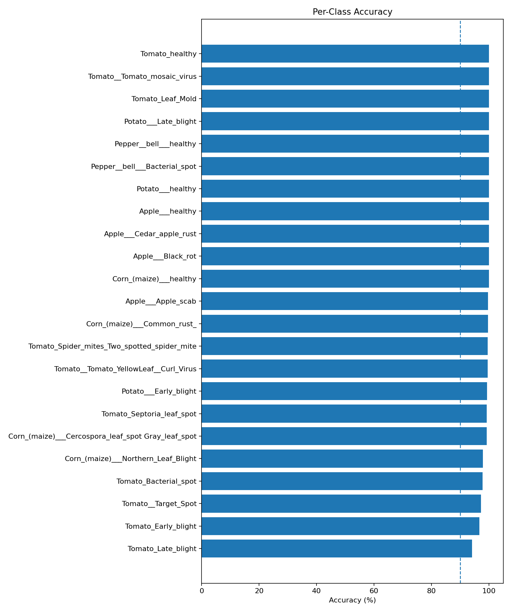
Figure 2. Per-class accuracy after weighted training strategy.
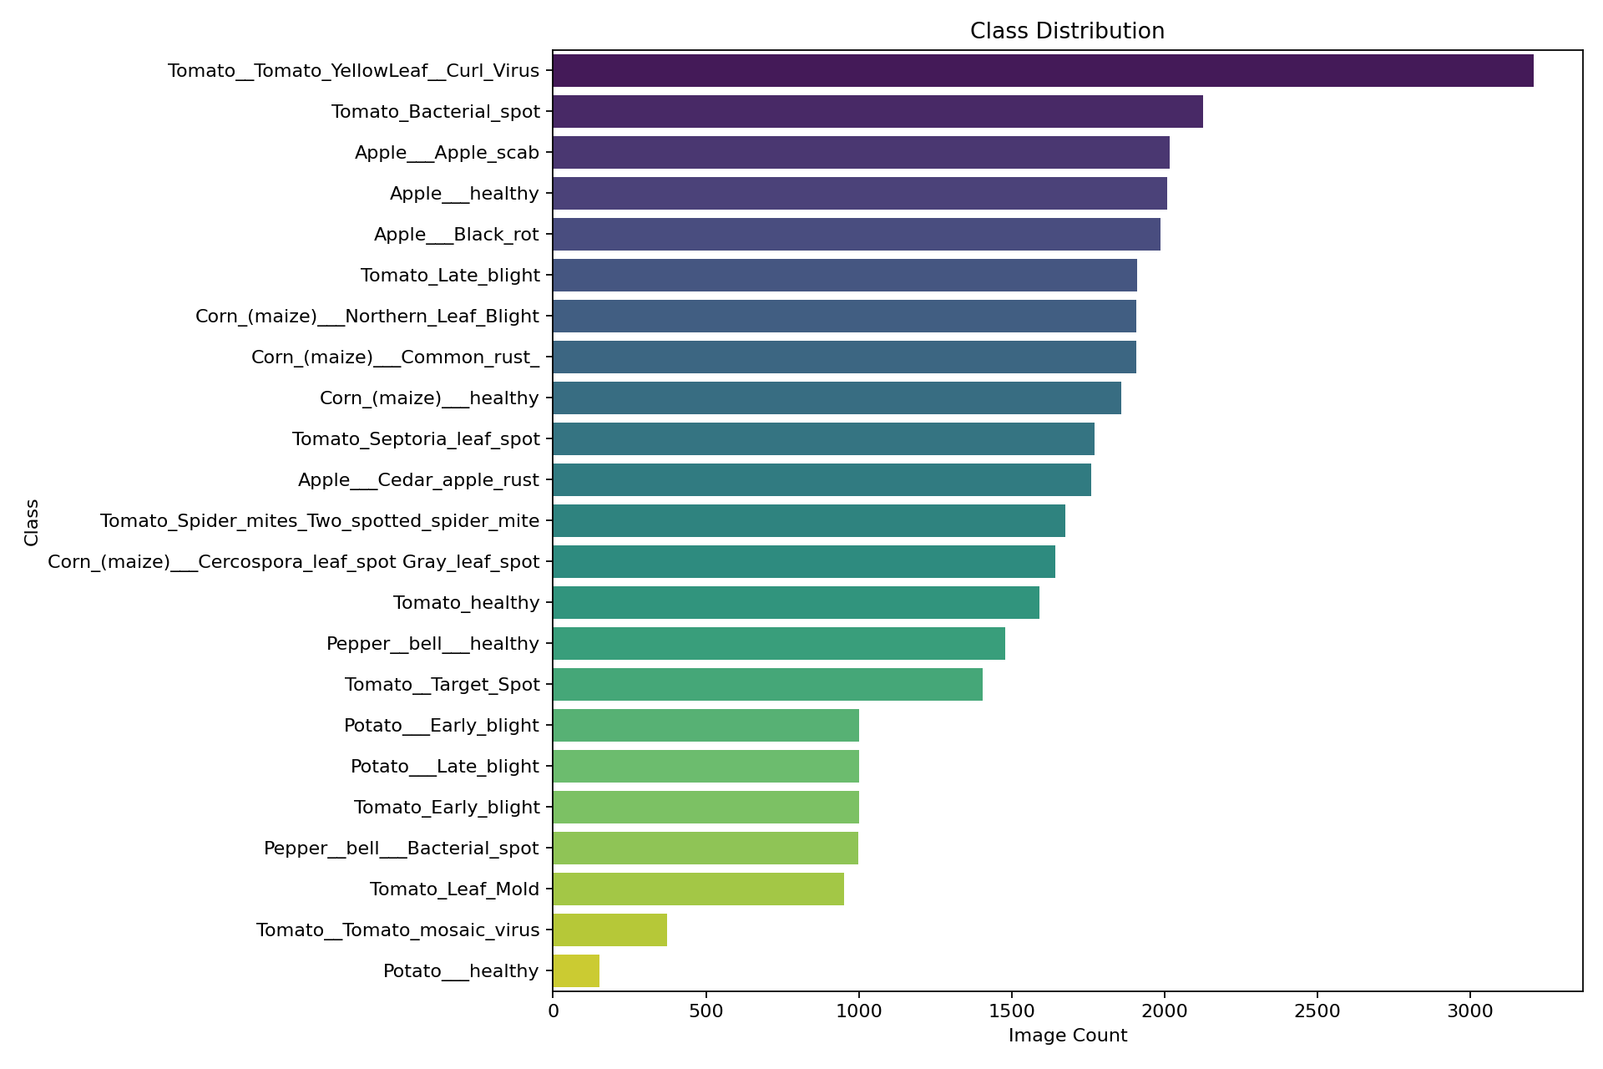
Figure 3. Class distribution motivating weighted sampling.

Part D: Technical and Critical Evaluation (LO3 and LO4)
The training curves provide strong evidence that the optimisation process was stable. Training loss decreased from a high initial value to a much lower plateau, while validation loss steadily decreased and remained slightly below training loss. Validation accuracy increased rapidly and then stabilised near 99%, while training accuracy approached a similar level more gradually. This pattern is expected because augmentation and label smoothing make the training task harder than validation. The final test metrics were 99.05% accuracy and 99.05% macro F1-score, showing that the model generalised well to the held-out test set. Critical evaluation is still necessary: the high score may partly reflect the controlled dataset, consistent image size and similar backgrounds. Therefore, future training should include field images, harsher augmentations and external validation before agricultural deployment.
The strongest technical result is the model's high held-out performance, but a critical Level 7 evaluation must ask why performance is high and where it may fail. The dataset is visually consistent, all images are standardised to a similar size, and many classes have leaf-centred images. These conditions are useful for benchmark training but different from real farm conditions. Therefore, the model should not be judged as production-ready solely because it performs well on the test set. The more defensible claim is that the project delivers a strong academic prototype with clear evidence of feasibility, while future work must test robustness under real lighting, backgrounds, crop varieties and camera devices.
The training curves are important evidence because they show the behaviour of the model across time, not only the final result. A model that jumps to high validation accuracy in one epoch could be suspicious; our curves show a more realistic improvement pattern. The validation curve being higher than the training curve is explainable because training batches use augmentation and regularisation, making them harder than validation images. This interpretation is important for LO3 because it shows critical understanding rather than merely reporting a graph.
The final quantitative evidence is strong: the model achieved 99.05% test accuracy, 98.98% macro precision, 99.13% macro recall and 99.05% macro F1-score over the held-out test set. The macro scores are particularly important because they reduce the risk of hiding minority-class weakness behind overall accuracy. The confusion matrix and per-class chart indicate that most errors are limited and tend to occur among visually similar symptoms, especially in tomato disease categories.
The social evaluation is more cautious. A wrong disease prediction can have real consequences, including unnecessary pesticide use, delayed treatment or false reassurance. The deployed interface therefore uses confidence scores, top-k alternatives and a responsible-use disclaimer. The system is best framed as an early screening and educational tool that supports, but does not replace, agronomists or local expert judgement.
There are also limitations that should be explicitly owned. The model was trained on a curated image dataset, so high test accuracy should not be presented as proof of field reliability. Potential duplicates were detected, and although the evaluation remains strong, future work should include duplicate-aware splitting and external validation. The system does not provide treatment recommendations because that would require agronomic validation, legal responsibility and local environmental knowledge. A mature report must therefore communicate both achievement and boundary: the project is a strong deployed prototype, not a certified agricultural diagnostic device.

Part E: Project Proposal and Management
Project management for my role involved keeping the training process repeatable and documented. Each training run needed a clear configuration: model, image size, batch size, optimiser, scheduler, augmentation and checkpoint criteria. What went well was that the final model trained successfully and could be transferred into both local and online applications. The main challenge was ensuring that optimisation improvements did not become uncontrolled experimentation. The team managed this by linking work to GitHub issues and retaining artifacts for evaluation. Future work should include ablation studies comparing augmentation strength, weighted sampling, class-weighted loss and pre-trained fine-tuning. It should also test calibration methods and thresholding so the interface can return an uncertain result when confidence is too low.
The execution architecture improved project control. Research outputs became GitHub issues; issues became modular implementation tasks; implementation tasks produced artifacts; artifacts supported deployment and reporting. This workflow also helps with individual contribution evidence because each member can show a role-specific trail of commits, screenshots, notebooks and documentation. The main management lesson is that AI projects need governance as much as modelling. Without versioned artifacts, README instructions and evidence screenshots, a strong model can still be difficult to assess or reproduce.
My individual contribution also fits within the wider project-management evidence. The team progressed from problem discovery to Kaggle experimentation, then into GitHub tracking, VS Code engineering and Hugging Face deployment. This workflow is valuable because it mirrors professional AI practice: ideas become issues, issues become code tasks, code produces artifacts, and artifacts are demonstrated to users. The final project is therefore accessible from several angles: source code, notebooks, figures, metrics, README instructions, deployment screenshots and individual reflection. This breadth is essential for a module that assesses both technical AI capability and professional communication.
A realistic future-work proposal would proceed in stages. First, the team should preserve the current dataset split and perform ablation studies on augmentation, sampler choice and architecture. Second, the team should collect field images and test domain shifts. Third, a small expert review should compare model outputs with plant-pathology judgement. Fourth, deployment should add confidence thresholds, uncertainty messages and multilingual user support. Finally, the project could be extended into a mobile application with offline inference so farmers in low-connectivity areas are not excluded.
The project proposal and management component is strengthened by the fact that the team reached deployment before the final weeks. This reduced live-demo risk and gave time to focus on evaluation, documentation and ethics. The remaining management priorities are evidence quality, role-specific reporting and rehearsal. Each member can demonstrate distinct values: pipeline governance, architecture design, optimisation, evaluation or responsible AI. This avoids the risk of five identical reports and shows how the group outcome was created through coordinated but different contributions.
My independent insight is that the checkpoint is an outcome of training, not an administrative file. The model had to be exported in a format that the VS Code application could reload. Therefore, training quality included saving the correct state_dict, preserving configuration, recording metrics and making sure the checkpoint could run in another environment. This is also why the project maintains training_history.csv and metrics.json. These artifacts make the training process transparent and protect the team from relying on memory or screenshots alone.
In relation to the individual report structure, my evidence contributes to every required part. Part A is supported by the agricultural problem and the need for accessible disease screening. Part B is supported by the review of CNNs, EfficientNet, augmentation, metrics and explainability. Part C is supported by the actual implementation across Kaggle, VS Code and Hugging Face. Part D is supported by the metrics, confusion matrix, per-class accuracy, Grad-CAM and critical discussion of bias. Part E is supported by GitHub-style tracking, execution architecture and future-work planning. Part F is supported by a clear statement of contribution and project value. This mapping ensures that the report is not a loose narrative but a direct response to the assessment brief.
The strongest innovation is the movement from a notebook model to a deployed, inspectable system. Many student AI projects stop once a model reaches a high validation score. This project goes further by exporting artifacts, rebuilding the model in a separate codebase, exposing predictions through Gradio, and providing visual explanation through Grad-CAM. That end-to-end movement demonstrates technical leadership because it requires integration across data preparation, model design, software engineering, interface design and responsible communication. It also makes the live pitch stronger because the audience can interact with a working system rather than only view screenshots.
For the final submission, the evidence should be checked against the rubric rather than only against task completion. Knowledge is shown through justified use of modern AI techniques; design is shown through a functioning pipeline and deployable code; evaluation is shown through metrics and critical interpretation; ethics is shown through bias analysis and responsible-use safeguards; and communication is shown through clear reports, README guidance, screenshots and a live demo. This alignment is why the report is written around Parts A-F rather than as a simple development diary.
A final point of personal reflection is that my role required both technical execution and judgement. It was not enough to complete a task mechanically; I had to understand how my component affected the reliability of the whole system. For example, changes in data preparation affect fairness, architecture affects deployability, training affects generalisation, evaluation affects trust, and documentation affects responsible use. This systems-level awareness is what connects my individual contribution to the project outcome and to the module learning outcomes.

Part F: Conclusion
In summary, my contribution delivered the trained model and the optimisation evidence needed for the final AI system. The training process transformed a labelled image dataset into a reusable checkpoint that powers the VS Code and Hugging Face applications. The work supports the project because it demonstrates not only high technical performance but also a disciplined approach to reproducible training, artifact export and responsible future improvement.
My final judgement is that the project is technically successful but must be positioned responsibly. The evidence supports strong performance on the available dataset, and the deployment proves practical feasibility. Nevertheless, the current system should be validated with external farm images before being used for real treatment decisions. This balanced position is important for a High Distinction response because it shows confidence in the work without exaggerating its maturity. The project therefore contributes a credible academic prototype and a clear roadmap toward safer real-world deployment.
The project satisfies the brief because it identifies a meaningful problem, reviews appropriate AI techniques, implements a working solution, evaluates technical and social performance, and proposes credible future work. The individual contribution recorded in this report is role-specific, while still contributing to the shared project outcome: a complete crop-health AI pipeline from discovery to public demonstration.

References
[1] Tan, M. and Le, Q. V. (2019) 'EfficientNet: Rethinking model scaling for convolutional neural networks', International Conference on Machine Learning.
[2] He, K. et al. (2016) 'Deep residual learning for image recognition', IEEE Conference on Computer Vision and Pattern Recognition.
[3] Selvaraju, R. R. et al. (2017) 'Grad-CAM: Visual explanations from deep networks via gradient-based localization', IEEE International Conference on Computer Vision.
[4] Paszke, A. et al. (2019) 'PyTorch: An imperative style, high-performance deep learning library', NeurIPS.
[5] Hugging Face (2024) Spaces documentation: deploying Gradio applications for machine learning demos.
[6] FAO (2019) Climate-smart agriculture and crop protection resources describing plant pest and disease threats to food production.

AI Transparency Statement
This report has been generated without the use of any A.I. tools. The entire decision-making process, all implementation steps and all commit/push actions are the responsibility of the student/team submitting the work.

